MHSA-TDL: Multi-Head Self-Attention-based Telemetry-driven Deep Learning Framework for Cluster Health Prediction and Failure Detection

Mahek Naaz
24217808
MSc in Cloud Computing
National College of Ireland

Abstract
With the advent of cloud computing, cloud cluster health prediction has become one of the most important topics of study for maintaining reliability, availability and resilience of cloud platforms. Existing monitoring techniques are largely reactive and cannot detect infrastructure degradation before service failures, leading to greater downtime, wasted resources, and violations of Service Level Agreements (SLAs). This study proposes the Multi-Head Self-Attention-based Telemetry-Driven Deep Learning (MHSA-TDL) framework for intelligent cloud cluster health prediction and early failure detection using cloud telemetry data. The proposed framework uses Multi-Head Self-Attention to automatically capture complex temporal relationships among telemetry metrics such as CPU utilisation, memory usage, disk I/O, network traffic, and scheduling events, without relying on feature engineering. This framework will be implemented and experimentally evaluated with the Google Cluster Trace dataset in a quantitative experimental approach. It will be evaluated based on its Accuracy, Precision, Recall, F1-Score, ROC-AUC and prediction latency and compared with the existing hybrid deep learning and traditional monitoring methods. The expected outcome is a more accurate & proactive prediction framework which leads to greater reliability of cloud infrastructure, lesser service downtime and intelligent cloud infrastructure management.

Keywords: Cloud Computing, Cloud Telemetry, Cluster Health Prediction, Failure Detection, Multi-Head Self-Attention.

Introduction
This section presented the background of the research, problem statement, research question, and the proposed framework for cloud cluster health prediction and failure detection. It also showed the expected research contributions and the structure of the proposal.

Background
Cloud computing has been rapidly adopted as the backbone of today's digital infrastructure, delivering scalable, on-demand computing services to applications in the healthcare, finance, education and enterprise sectors (Tyagi et al., 2025). The growing scale of cloud deployments has made keeping clusters healthy increasingly difficult with dynamically shifting workloads, resource variability, and metrics like CPU utilisation, memory use, disk I/O and network traffic changing constantly. Most traditional monitoring methods are based on pre-defined thresholds and alerting when failures have occurred, and system performance has degraded. Hence, there is a growing demand for intelligent prediction frameworks that can analyze cloud telemetry data proactive to enhance the reliability of the infrastructure, reduce downtime, and ensure compliance to Quality of Service (QoS) and Service Level Agreement (SLA).

Problem Statement and Research Motivation
Dynamic workloads, large-scale distributed infrastructures and constantly changing telemetry data have made maintaining cloud cluster health more difficult (Devalla, 2025). Cloud monitoring solutions currently available mostly work reactively, notifying about failures when performance has degraded which can lead to service disruptions, waste of resources and Service Level Agreement (SLA) violations (Malik, 2026). In recent years, deep learning methods have seen increased success in predicting failures, but many are only able to classify tasks and are less effective in capturing multiple cloud telemetry metrics in complex relationships. These constraints are what inspire the creation of a smarter prediction system to anticipate the health of cloud clusters, detect potential cluster failure early with a high degree of accuracy, and enable reliable, resilient and efficient management of cloud infrastructure.

Proposed Research Question
What is the performance of the proposed framework in predicting cloud cluster health and detecting potential failures with the help of cloud telemetry data compared with existing hybrid deep learning and traditional monitoring approaches?
To solve and address this question the research proposes the Multi-Head Self Attention based Telemetry-driven Deep Learning (MHSA-TDL) Framework. This combines cloud telemetry analytics with a Multi-Head Self-Attention-based deep learning architecture capable of automatically learning complex temporal dependencies among multiple telemetry metrics. Unlike existing hybrid approaches that mainly trusts on manual feature selection and traditional machine learning classifiers, the proposed framework performs end-to-end cluster health prediction and early failure detection to support proactive cloud infrastructure management.

Research Contributions and Expected Impact
The proposed Framework contributes cloud computing research by developing an intelligent telemetry-driven prediction framework that is based on Multi-Head Self-Attention for enhancing cloud cluster health prediction and the early detection of failures. The framework is expected to better capture the interactions between multiple telemetry metrics, than existing GRU-based hybrid approaches do, leading to better prediction accuracy and earlier detection of abnormal cluster behaviour. The research is also an extensive experimental analysis with the current approaches, giving meaningful insights into the effectiveness of attention-based deep learning in predictive cloud infrastructure management. The expected outcomes will be the result of improved resource utilisation, less service downtime, greater system reliability, and higher SLA compliance in large-scale cloud environments.

Structure of the Research Proposal
The research proposal is divided into three sections. In Section 1, it provides the research background, research problem, research question, proposed MHSA framework (MHSA-TDL), expected contributions, and overall research structure. In Section 2 a summary analysis review of the literature related to cloud telemetry, cloud cluster health prediction, deep learning techniques and attention-based failure prediction is shown. Section 3 describes the proposed research methodology, system architecture, implementation resources, performance evaluation strategy, ethical considerations and project timeline for developing and validating the proposed framework.

Literature Review
This section reviewed existing studies on cloud telemetry and deep learning-based failure prediction by showing the limitations of current approaches. These identified research gaps provide the foundation for the proposed MHSA-TDL framework presented in the next section.

Cloud Telemetry for Intelligent Cluster Monitoring
Cloud telemetry has been integrated in the intelligent cloud cluster monitoring, which provides continuous monitoring of cloud resources like CPU utilisation, memory usage, disk I/O, network traffic, and scheduling events across distributed cloud resources (Sahoo et al., 2025). Unlike conventional threshold-based monitoring systems, the telemetry-based monitoring gives live view of cluster behaviour and allows for data-driven analysis of cluster system performance and cluster resource usage. Cloud telemetry has been shown to enable the detection of previously unknown workload patterns (Gouri et al., 2026), resource anomalies and signs of degradation of the infrastructure, which boosts service reliability and decreases the risk of unexpected service disruptions. The increasing volume, velocity and complexity of telemetry data has its challenges in relation to traditional monitoring methods, as many are unable to capture the complex temporal relationships between multiple performance measures. In large-scale cloud computing systems the growth of advanced deep learning approaches and cloud telemetry becomes a highly good and suitable approach for achieving intelligent cluster health prediction, advanced failure detection and autonomous cloud infrastructure management.

Cloud Cluster Health Prediction and Predictive Infrastructure Management
The prediction of the health of a cloud cluster is an important research field for enhancing the reliability, availability and efficiency of the modern cloud computing environment (Hasan and Hameed, 2025). Predictive infrastructure management analyzes historic cloud data and current cloud metrics as part of the process, looking for signs of service degradation and possible failure in the future before they impact service delivery, unlike reactive monitoring (Chandra Thota, 2024). In recent years, deep learning-based methods have shown promising results in learning complex temporal patterns from cloud telemetry data, which can be used for proactive maintenance and intelligent resource management. But it's difficult to model the dynamic cloud workloads with long-term dependencies properly. Hence this study offers great promise in augmenting the accuracy of failure detection and enabling autonomous, resilient, cloud infrastructure management by combining advanced attention-based deep learning architectures with cloud telemetry.

Deep Learning Approaches for Cloud Failure Prediction

With the development of the Internet of Things, cloud computing has become a hot research topic recently, which uses deep learning to predict the failure of clouds and enhance the management of resources, service reliability, and fault tolerance. Study (Aldomi et al., 2026) proposed a hybrid approach for feature selection using SelectKBest and feature extraction of the failure sequences from the sequences using a GRU network for the multiclass task failure prediction system using machine learning classifiers, which would help to identify the task failures earlier and decrease the number of SLA violations by allocating resources proactively. (Tengku Asmawi et al., 2022) compared in detail the traditional machine learning and deep learning models for predicting cloud failures at the job/task level based on Google Cloud Traces, emphasizing the significance of analyzing the features and evaluating the scalability of both learning paradigms, and showed that both machine learning and deep learning are able to predict cloud failures at the job/task level.

Extending predictive capabilities to autonomous recovery, (Singh and Rastogi, 2026) proposed an LSTM-based intelligent self-healing framework able to continuously monitor cloud telemetry, predict imminent failures, and automatically execute recovery actions like container restart, virtual machine migration and dynamic resource scaling to improve service availability and reduce recovery time. Likewise, (Wu, 2025) proposed a predictive fault detection system which consists of continuous monitoring, real-time machine learning–based fault prediction, and adaptive feedback to optimize the allocation of cloud resources and minimize cloud downtime by continuous learning. In total, the studies show the ability of deep learning models when combined with feature selection, smart monitoring, and automatic resource management to strongly improve the prediction of cloud failures, operational resilience, resource usage, and cloud service reliability in general.

Attention based Deep Learning for Cloud Failure Prediction
Cloud failure prediction is a challenging task, especially due to the complex temporal, semantic and contextual dependencies in large-scale operational data sets, which has been addressed by the attention-based deep learning approach. To leverage both semantic information and the temporal context of system logs, (Deng et al., 2024) introduced the Time-Aware Attention-Based Transformer (TAAT) which simultaneously uses both semantic information and timing information from system logs, using a time-aware attention mechanism. TAAT merges temporal relationships with Transformer-based feature learning, significantly improving the model's prediction accuracy by around 10% compared with the existing conventional log-based model without considering the temporal information in the system logs, on a real-world Alibaba Cloud dataset, which consists of 2.7 billion system logs.

In (Mohammed et al., 2025) a new framework for predictive failure detection for multivariate telemetry log analysis of cloud infrastructure is presented, leveraging Temporal Convolutional Networks (TCNs), attention-based deep learning and reinforcement-guided optimization. With more than 98.1% detection accuracy, the framework also missed less than 27% of the anomaly events as compared to using traditional monitoring methods, accurately identifying anomalies across compute, storage, networking and orchestration layers.

Moreover, (Tripathi et al., 2025) proposed GQAT-Net, which combines grouped query attention, multi-scale gated convolutions, transformer layers, and calibration mechanisms to detect task and job failures in large-scale distributed cloud and IoT-edge settings with uncertainty. GQAT-Net was tested on Alibaba and Google cluster trace data, with an average precision rate over 96%, indicating that the algorithm has high prediction accuracy, is suitable for the heterogeneous workload, and can be used to guide the proactive management of resources. So these studies provide a comprehensive picture of how attention-based deep learning models can improve cloud failure prediction by capturing temporal dependency, context and uncertainty, fostering greater prediction accuracy, system reliability and optimisation of resources.

Table 1: Critical analysis Table

Ref. | Key Contribution | Strengths | Limitations / Research Gap
Baseline: (Aldomi et al., 2026) | Introduced a hybrid framework combining feature selection with GRU-based temporal feature extraction and ML classifiers for early prediction of cloud task failures. | Achieved very high prediction performance, reduced SLA violations, identified optimal feature subset and captured temporal type of workload dependencies for proactive resource allocation. | Evaluated only on Google Cluster Trace dataset which is mainly focused on prediction rather than automated recovery, and did not consider energy performance.
(Tengku Asmawi et al., 2022) | Provided a good benchmark comparing ML and DL algorithms, feature importance analysis and scalability evaluation for cloud failure prediction. | Showed valuable insights into model selection, scalability and influential workload features for cloud failure prediction. | Mainly did a comparative study without proposing a novel deep learning architecture. Traditional ML slightly outperformed DL.
(Singh and Rastogi, 2026) | Combined deep learning-based failure prediction with autonomous recovery mechanisms. | Combined predictive analytics with automated remediation, reduced MTTR, improved service availability and improved operational performance through self-healing capabilities. | Focused mainly on infrastructure recovery rather than optimizing prediction accuracy with limited discussion of deployment overhead.
(Wu, 2025) | Proposed an adaptive monitoring and prediction framework that continuously learns from operational feedback to optimize cloud resource allocation. | Improved fault detection accuracy, resource utilization and operational reliability through recursive type of learning and predictive analytics. | Relied on traditional ML and standalone deep learning models without advanced sequence-learning architectures or attention mechanisms.
Baseline:(Deng et al., 2024) | Introduced a Transformer-based framework that jointly learns semantic log features and timestamp relationships using a time-aware attention mechanism for cloud failure prediction. | Integrates temporal and semantic information effectively; improves failure prediction accuracy by ~10% over existing log-based models; validated on a large-scale real-world Alibaba Cloud dataset (2.7 billion logs); suitable for production deployment. | Relies primarily on system log data and timestamp information, without incorporating infrastructure telemetry (CPU, memory, network, etc.); computational complexity of Transformer models may limit deployment in resource-constrained environments; uncertainty estimation is not considered.
Baseline:(Mohammed et al., 2025) | Developed a hybrid deep learning framework combining Temporal Convolutional Networks (TCNs), attention mechanisms, and reinforcement-guided optimization for multivariate cloud telemetry analysis. | Achieves high detection accuracy (>98%); analyzes heterogeneous telemetry across compute, storage, networking, and orchestration layers; fast training (<2.1 s/batch); includes SHAP and TCAV for explainable AI, improving model interpretability. | Evaluation focuses mainly on anomaly detection rather than long-horizon failure forecasting; reinforcement optimization increases architectural complexity; validation is limited to experimental cloud environments with limited discussion on cross-provider generalization.
(Tripathi et al., 2025) | Proposed an uncertainty-aware attention model integrating grouped query attention, multiscale gated convolutions, Transformer layers, and calibration techniques for task/job failure prediction. | Captures both temporal and spatial dependencies; provides uncertainty-aware predictions for reliable decision-making; achieves very high precision (96–98%) on Alibaba and Google cluster traces; supports proactive resource management in heterogeneous cloud-edge environments. | Focuses primarily on application-level task/job failures instead of infrastructure-level failures; increased architectural complexity may require substantial computational resources; real-time deployment overhead and scalability under continuously evolving cloud workloads require further investigation.

Identified Research Gaps
While the previous works have made significant strides in cloud failure forecasting via machine learning and deep learning and attention-based approaches, there are still some research gaps. The majority of approaches are on the task level where they either offer failure prediction, anomaly detection or log-based analysis, but not a holistic view on the overall health of the cloud cluster based on multivariate cloud telemetry. Handcrafted feature selection is commonly used in hybrid frameworks, and infrastructure telemetry like CPU and memory, disk i/o, network utilisation are not fully leveraged in Transformer-based models, except for system logs. Additionally, few efforts have been made to learn the long-range dependencies directly from a diverse telemetry dataset for cluster-level prediction. To mitigate these shortcomings, in this work, a MHSA-TDL Framework is introduced that combines Multi-Head Self-Attention with cloud telemetry to automatically learn complex temporal relationships, thereby achieving accurate health prediction of cloud clusters and early detection of failures, and enhancing the reliability, proactive management of infrastructure, and cloud service resilience.

Research Method & Specification
This section presented the proposed MHSA-TDL framework which includes the research methodology, implementation resources, system framework, performance evaluation strategy, ethical considerations and project timeline.

Proposed Research Methodology
In this study, quantitative experimental research methodology will be used to design, develop, and test the proposed MHSA-TDL system for predicting the health of cluster of Clouds and detecting failures as shown in Figure 1. The methodology aims to design an intelligent prediction framework which can learn complex temporal relationships from the cloud telemetry data in order to detect unhealthy cluster conditions well before a service failure happens. Cloud telemetry data will be gathered from the Google Cluster Trace dataset, such as CPU utilisation, memory utilisation, disk I/O, network traffic, task scheduling events and machine resource information, initially. All data is going to be preprocessed, such as data cleaning, missing value treatment, feature normalisation, sequence generation and partitioning of the training, validation, and test sets. Next, an advanced deep learning model based on temporal feature learning will be built, following preprocessing, to capture the hidden behavioural patterns related to cluster degradation. The objective is to optimize the prediction performance, minimize overfitting, and conduct Hyperparameter optimisation and Cross-Validations.
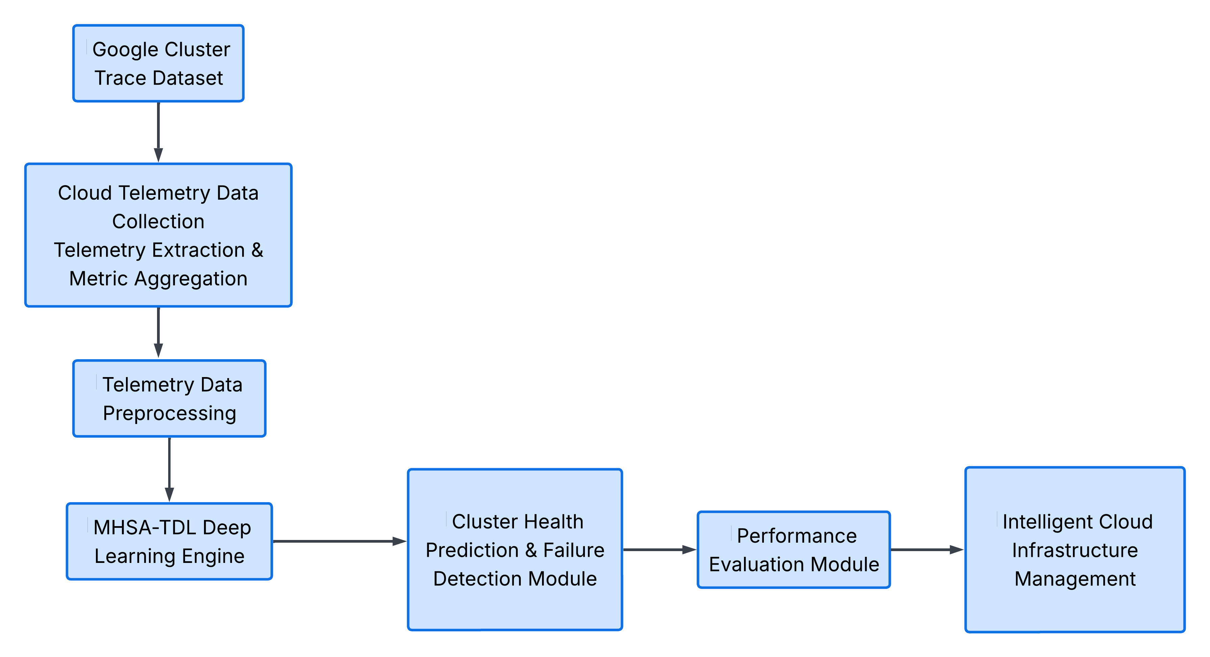
Figure 1: System Architecture Diagram

Research Resources
The developed proposed MHSA-TDL framework will be built upon commonly accepted, open-source software, cloud computing platforms and publicly accessible datasets, thus affording the reproducibility and low-cost experimentation. The primary language will be Python and deep learning models will be implemented and trained using TensorFlow and PyTorch. The tools used for telemetry preprocessing, statistical analysis and performance evaluation will be Pandas, NumPy and Scikit-learn (Hill et al., 2024) while Matplotlib will be used for graphical visualization of experimental results. The Google Cluster Trace dataset will contain detailed cloud telemetry data, such as processor utilization, memory allocation, storage usage, scheduling events, and machine-level resource information for model building. Google Colab and AWS EC2 GPU enabled virtual machines will be used for model training and experimentation to speed up the computational performance. Each version control and experiment management will be used throughout the project using GitHub as is presented in Table 2. All these software tools, data and cloud resources offer an efficient and scalable platform to implement, validate and analyse the proposed deep learning framework.
Table 2: Research Resources
Component | Resource
Programming Language | Python
Deep Learning Libraries | TensorFlow, PyTorch
Data Processing | Pandas, NumPy, Scikit-learn
Visualisation | Matplotlib
Dataset | Google Cluster Trace Dataset
Cloud Platform | Google Colab, AWS EC2 (GPU)
Version Control | GitHub

Proposed CTDLF Framework
The proposed MHSA-TDL model is end-to-end intelligent prediction pipeline to convert raw cloud telemetry to cluster health insights. First, the cluster of clouds is constantly monitored for various telemetry metrics such as CPU usage, CPU memory, CPU disk I/O, CPU network traffic, and scheduling events (Kapetanidou et al., 2026). These raw metrics are then preprocessed using a variety of data cleaning, missing value imputation, feature normalisation and sequential data preparation techniques to enhance data quality and learning efficiency. The processed telemetry sequences are then used to automatically learn complex temporal relationships and hidden connections between various telemetry features over long observation windows using Multi-Head Self-Attention. The proposed Transformer-based architecture does not require manually designed feature selection and offers a more complete cloud cluster behaviour understanding compared to the baseline, which is a combination of the Random Forest (RF), K-Nearest Neighbor (KNN), Support Vector Machine (SVM) and Gated Recurrent Unit (GRU) models. The framework not only predicts the health of each cluster but also detects failures before service disruption, using the learned representations. Lastly, the results of the prediction is compared with the pre-defined performance metrics, which in turn feed into a proactive management of the cloud infrastructure based on early warning generation, intelligent resource planning and minimisation of service downtime.

Performance Evaluation Framework
The suggested MHSA-TDL framework will be tested in a practical way, and its predictive performance as well as operational effectiveness metrics will be assessed, to be able to measure its suitability in proactive management of cloud infrastructures. The ability of the framework to correctly classify the healthy and unhealthy cluster states will be evaluated based on Accuracy, Precision, Recall, F1-Score and ROC-AUC. To evaluate the prediction reliability, the false positive and false negative predictions will be analyzed using confusion matrix analysis. Besides prediction quality, prediction latency will be measured to check the real-time monitoring requirement of the framework.

Ethical and Responsible Research Considerations
Proposed research has no ethical concerns, only using publicly available and anonymised cloud telemetry data, and no personal information is collected, no human subjects involved. All datasets will be used in line with the licensing conditions and research usage policy for the dataset. All data preprocessing, model building, parameter setting and experimental evaluation steps will be well documented to ensure research transparency and reproducibility. Cross validation and independent testing will be used as appropriate validation techniques to ensure that the models are not overly biased and can be generalised to different cloud workload scenarios. Experimental results will be presented in an objective manner without manipulation and selective presentation of results, thus reflecting academic integrity and scientific credibility. The study will adhere to all ethical standards and will encourage the responsible use of AI in managing cloud infrastructure with intelligence.

Project Plan and Timeline

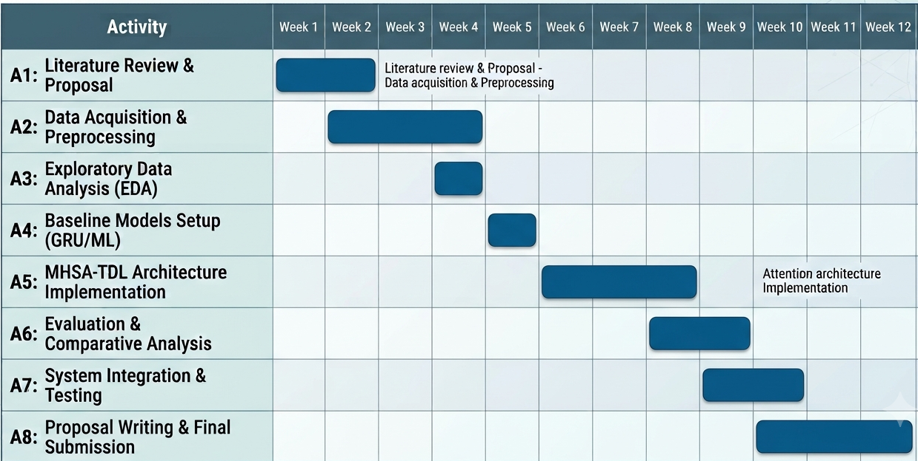

References

Aldomi, S., Suleiman, H., Shatnawi, A., Alawneh, L., 2026. A deep learning approach for early prediction of task failures in cloud computing environments. Syst. Soft Comput. 8, 200442 . https://doi.org/10.1016/j.sasc.2026.200442 Google Scholar citation:4
Chandra Thota, R., 2024. AI-Augmented Predictive Analytics for Proactive Cloud Infrastructure Management. J. Sci. Technol. 5, 246–264. https://doi.org/10.55662/JST.2024.5407 Google Scholar citation:12
Deng, L., Wang, Y., Wang, H., Ma, X., Du, X., Zheng, X., Wu, D., 2024. Time-Aware Attention-Based Transformer (TAAT) for Cloud Computing System Failure Prediction, in: Proceedings of the 30th ACM SIGKDD Conference on Knowledge Discovery and Data Mining. Presented at the KDD ’24: The 30th ACM SIGKDD Conference on Knowledge Discovery and Data Mining, ACM, Barcelona Spain, pp. 4906–4917. https://doi.org/10.1145/3637528.3671547 Core Rank A+
Devalla, S., 2025. AI-Driven Telemetry Analytics for Predictive Reliability and Privacy in Enterprise-Scale Cloud Systems. Int. J. Artif. Intell. Data Sci. Mach. Learn. 6. https://doi.org/10.63282/3050-9262.IJAIDSML-V6I2P114 Google Scholar citation 5
Gouri, F., Kota, C.P.K., Shivnatri, M., Jain, K., 2026. AutoScaleAI: An AI-Powered Framework for Cloud Resource Optimization Using Telemetry Analytics. IEEE Access 14, 49082–49098. https://doi.org/10.1109/ACCESS.2026.3677437 JCR Impact factor:3.4
Hasan, R.A., Hameed, T.M., 2025. Optimizing Cloud Computing: Balancing Cost, Reliability, and Energy Efficiency. Babylon. J. Artif. Intell. 2025, 64–71. https://doi.org/10.58496/BJAI/2025/006 Google Scholar citation :16
Hill, C., Du, L., Johnson, M., McCullough, B.D., 2024. Comparing programming languages for data analytics: Accuracy of estimation in Python and R. WIREs Data Min. Knowl. Discov. 14, e1531. https://doi.org/10.1002/widm.1531 Google Scholar citation:51
Kapetanidou, I.A., Kotsiopoulos, T., Thanasoulis, G., Bizopoulos, P., Liatifis, A., Skoularikis, M., Nizamis, A., Sarigiannidis, P., Votis, K., 2026. A telemetry dataset on resource utilisation and power consumption in the edge-cloud continuum. Data Brief 66, 112734. https://doi.org/10.1016/j.dib.2026.112734 Google Scholar citation:1
Malik, M.Y., 2026. Reducing Alert Fatigue in Cloud Operations: A Practitioner’s Approach to Scalable SRE Monitoring. https://doi.org/10.36227/techrxiv.176765375.53124342/v1 Google Scholar citation:1
Mohammed, A.K., Al-Attar, B., Alzamily, H., Almaiah, M.A., Hasan, Taif.S., Ataalla, A.F., Solke, N., Shah, P., Sekhar, R., 2025. Predictive Failure Detection in Cloud Infrastructure Using Multivariate Telemetry Log Analysis with Temporal Convolution and Attention-Based Deep Learning, in: 2025 3rd International Conference on Cyber Resilience (ICCR). Presented at the 2025 3rd International Conference on Cyber Resilience (ICCR), IEEE, Dubai, United Arab Emirates, pp. 1–8. https://doi.org/10.1109/ICCR67387.2025.11292090 Google Scholar citation:3
Sahoo, I., Devarapalli, S., Tyagi, J., Bidkar, D.M., Srivastava, M., Adepu, P.K., Kole, D., Ingole, B.S., 2025. Auto-Tuning AI Cloud Infrastructure via Real-Time Telemetry-Driven Feedback Loops, in: 2025 International Conference on Artificial Intelligence and Machine Vision (AIMV). Presented at the 2025 International Conference on Artificial Intelligence and Machine Vision (AIMV), IEEE, Gandhinagar, India, pp. 1–5. https://doi.org/10.1109/AIMV66517.2025.11203439 Google Scholar citation:5
Singh, A.K., Rastogi, R., 2026. Intelligent Self-Healing Cloud Systems Using Deep Learning-Based Failure Prediction. Google Scholar citation:0
Tengku Asmawi, T.N., Ismail, A., Shen, J., 2022. Cloud failure prediction based on traditional machine learning and deep learning. J. Cloud Comput. 11, 47. https://doi.org/10.1186/s13677-022-00327-0 Google scholar citation:63
Tripathi, S., Gupta, P., Misra, R., Singh, T.N., 2025. GQAT-Net: A Calibrated Attention Model for Failure Prediction in Large-Scale Distributed Systems. J. Grid Comput. 23, 25. https://doi.org/10.1007/s10723-025-09813-6 Google Scholaer Citation:2
Tyagi, A.K., Hemamalini, V., Kumari, S., Tripathi, K., 2025. Future of Digital Tools, Information Technologies, and Cloud Services for Building Effective Software Tools for the Modern Generation:, in: Sharma, A.K., Nitin, Kumar, S. (Eds.), Advances in Computational Intelligence and Robotics. IGI Global, pp. 577–592. https://doi.org/10.4018/979-8-3693-9694-0.ch025 Google Scholar citation:4
Wu, W., 2025. Fault Detection and Prediction in Models: Optimizing Resource Usage in Cloud Infrastructure, in: Proceedings of the 2025 4th International Conference on Intelligent Systems, Communications and Computer Networks. Presented at the ISCCN 2025: 2025 4th International Conference on Intelligent Systems, Communications and Computer Networks, ACM, Nanjing China, pp. 131–138. https://doi.org/10.1145/3732945.3732964 Google Scholar Citation:19

